

Midlands State University

Website Report

September 2022

## Webometric Ranking

The primary objective of the webometrics is to promote open access to the knowledge generated by the University. The best strategy to improve ranking is to increase the quantity and quality of electronic research output.

## Current Ranking Criteria

|  |  |  |  |  |
| --- | --- | --- | --- | --- |
| INDICATORS | MEANING | METHODOLOGY | SOURCE | WEIGHT |
| VISIBILITY | Web contents Impact | Number of **external networks** (subnets) linking to the institution's webpages | Ahrefs  Majestic | **50%** |
| TRANSPARENCY (or OPENNESS) | Top cited researchers | Number of **citations** from **Top 210 authors** (excl. **top 20 outliers**) | Google Scholar  Profiles | **10%** |
| EXCELLENCE (or SCHOLAR) | Top cited papers | Number of **papers** amongst the top 10% most cited in each one of the 27 disciplines of the full database  Data for the five-year period: **2017-2021** | Scimago | **40%** |

## Zimbabwe Ranking

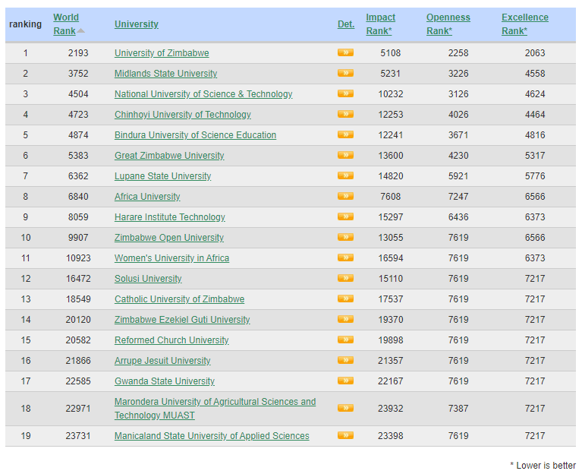

## Africa Ranking

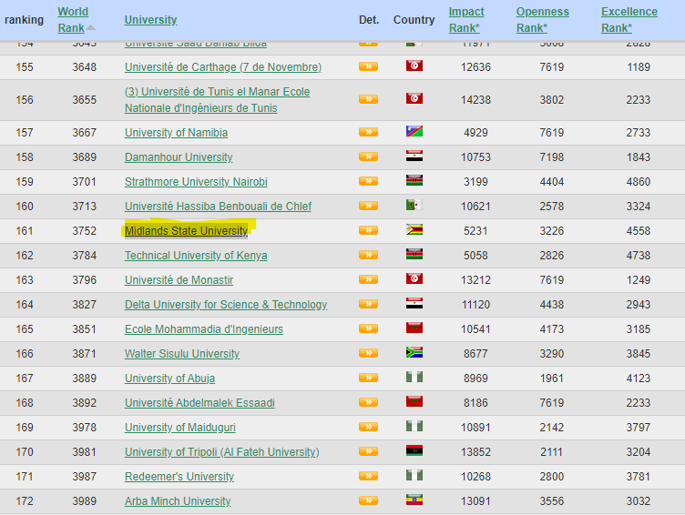

## African Ranking Trend

Below is a graph showing how the University African Webometric ranking has changed from January 2018–September 2022

## African Ranking Breakdown

Below are the changes of individual ranking criteria from July 2019- September 2022. **The lower the numerical ranking the better.**

|  |  |  |  |  |  |  |  |  |
| --- | --- | --- | --- | --- | --- | --- | --- | --- |
| Ranking Criteria | Jul-19 | Jan-20 | Jul-20 | Jan -21 | Jul-21 | Jan-22 | Sept-22 | Difference |
| Presence | 15 | 15 | 33 | N/A | N/A | N/A | N/A | N/A |
| Impact | 137 | 143 | 138 | 146 | 140 | 81 | 80 | **+1** |
| Openness | 197 | 200 | 154 | 140 | 145 | 164 | 178 | **-14** |
| Excellence | 191 | 187 | 227 | 244 | 243 | 262 | 267 | **-5** |

## Citation Analysis

Below is the analysis of citations after removing top 20 outliers from 6 local universities according to Google Scholar. **The higher the citation the better**

The above chart highlights University of Zimbabwe is clearly better in terms of citations as compared to other institutions.

## RECOMMENDATIONS

* **Openness Ranking** can be improved by publishing more research papers in internal and external journals and institutional repository
* **Impact Ranking** can be improved by publishing high quality papers and follow up marketing efforts
* **Excellence Ranking** can be improved by publishing high quality papers that can be part of the 10% most cited papers in high impact international journals